**Container orchestration using kubernetes and route application using**

**ingress controller**

**Description**

Deploy two different web applications in kubernetes and create a single route

using K8s Ingress controller.

**Infrastructure setup**

Setup Infrastructure in AWS using terraform to create EC2 using Windows

command prompt.

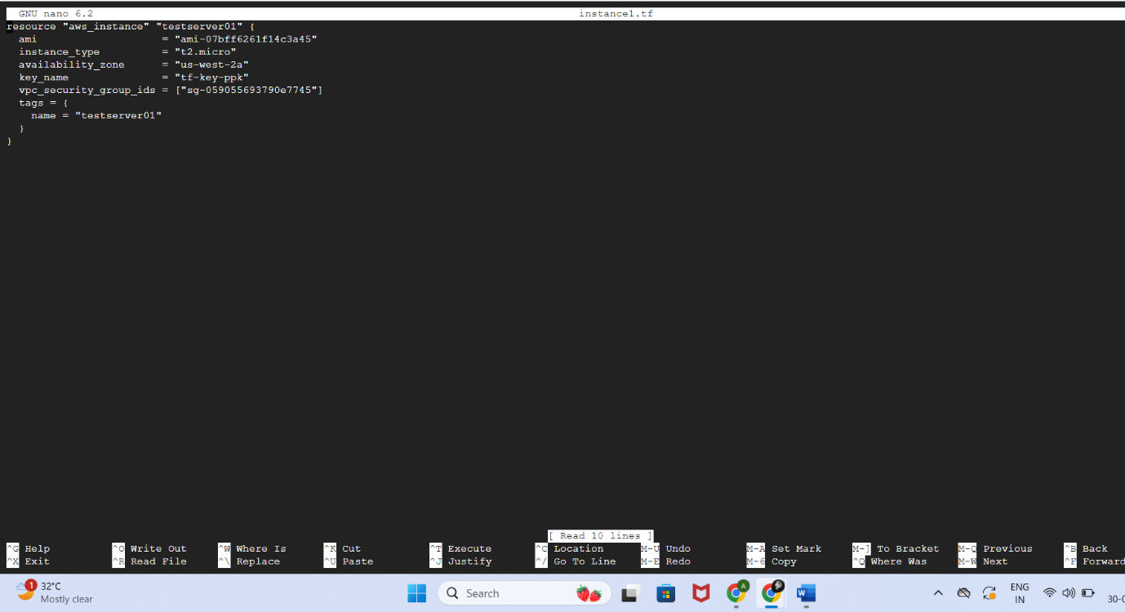

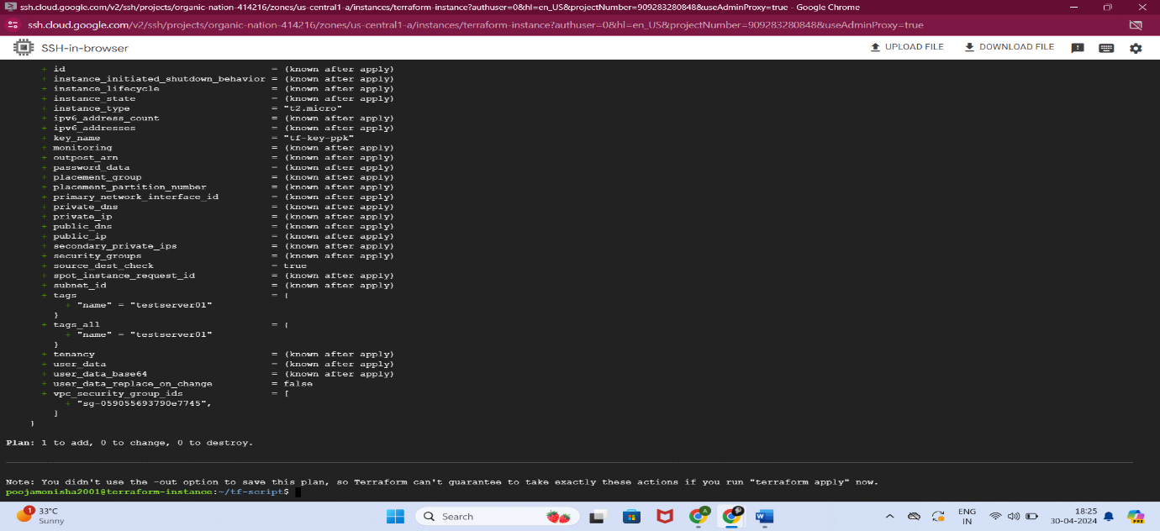

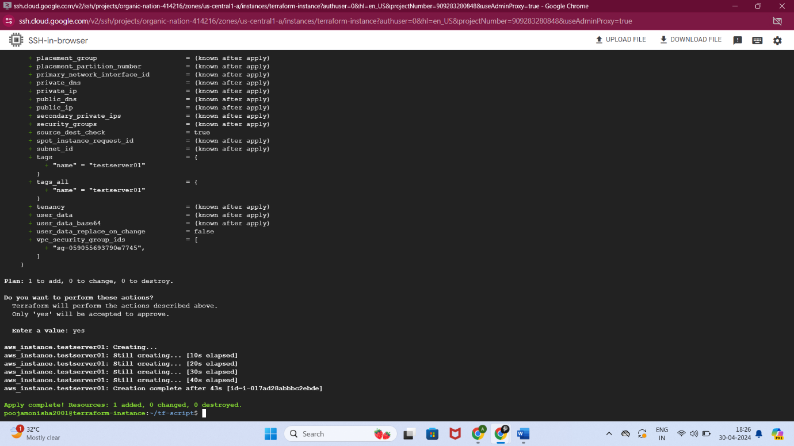

Instance created in AWS using the terraform

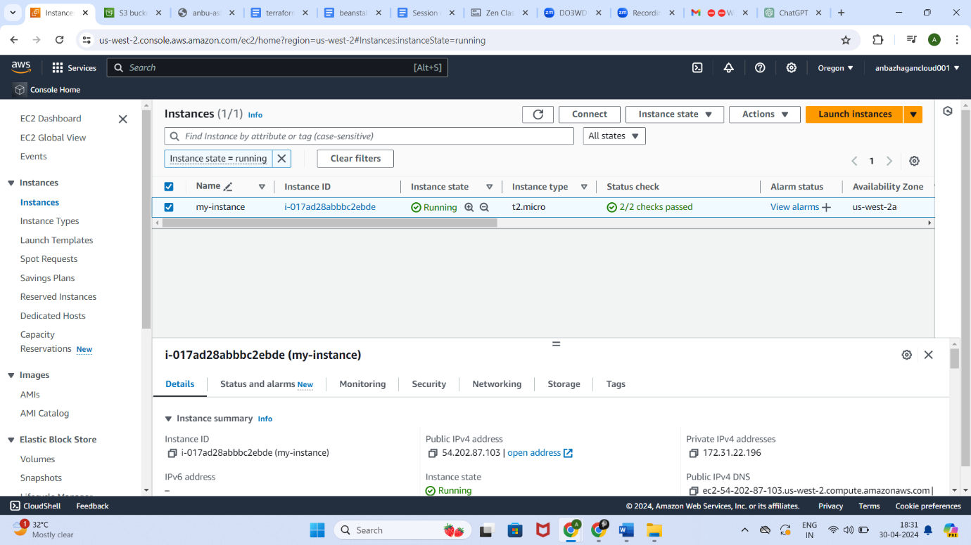

**Kubernetes setup**

Create K8s cluster using EKS command line interface (1 Master and 3 Worker

nodes).

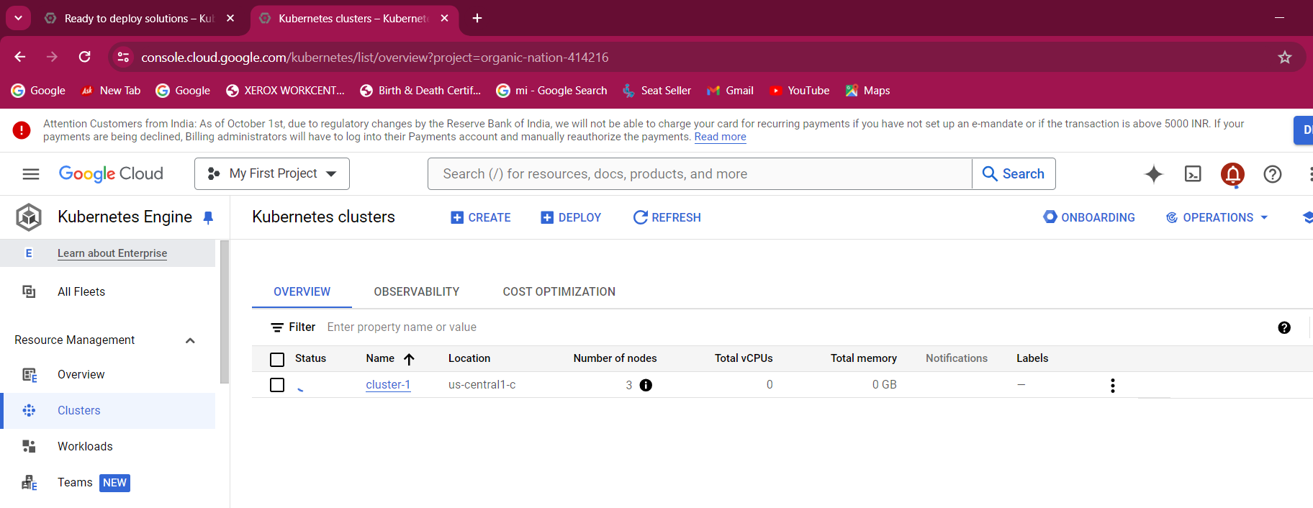

**Deploy Application**

Deploy 2 different applications using deployment.yml files (Create 2 different yml

files and apply using K8s command line interface).

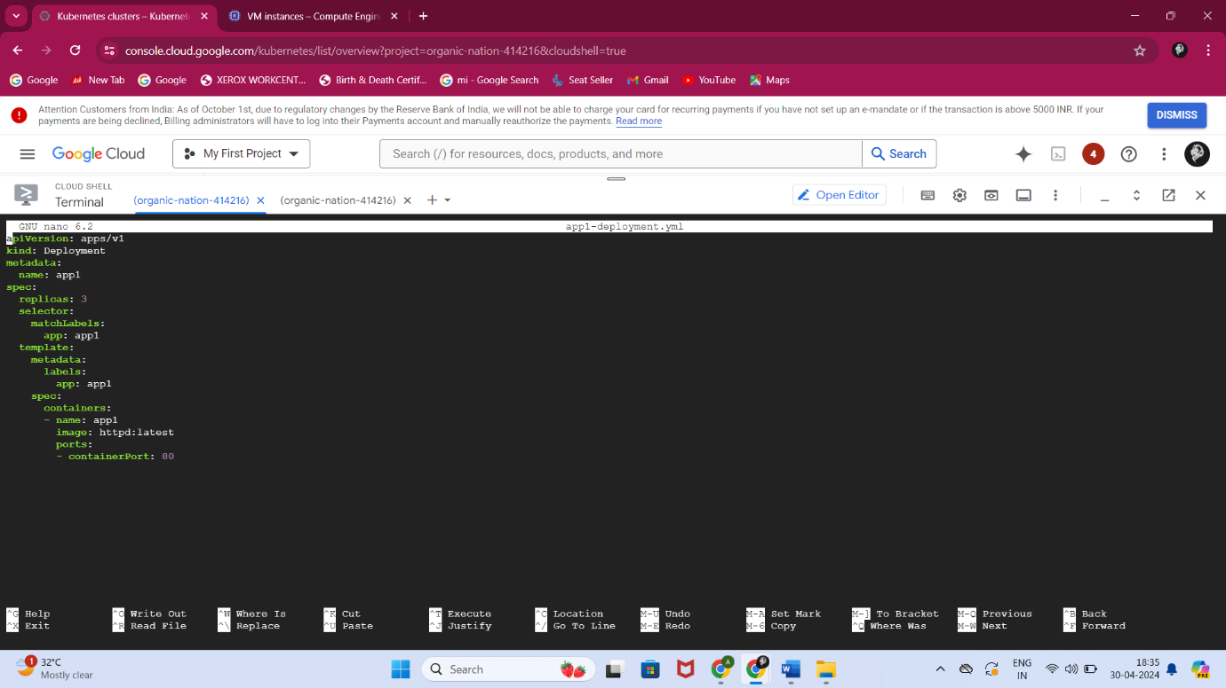

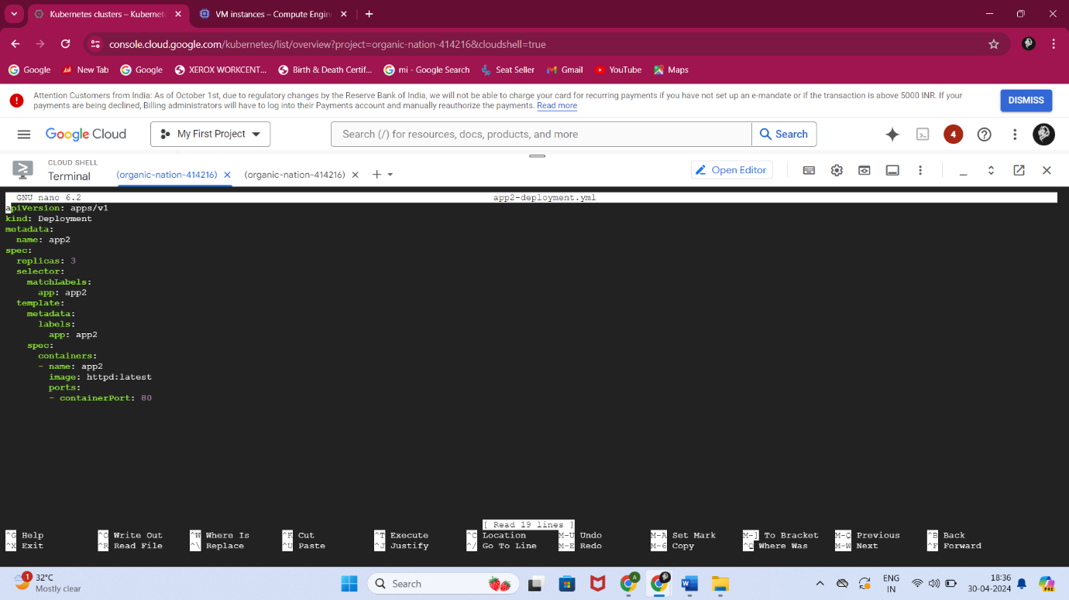

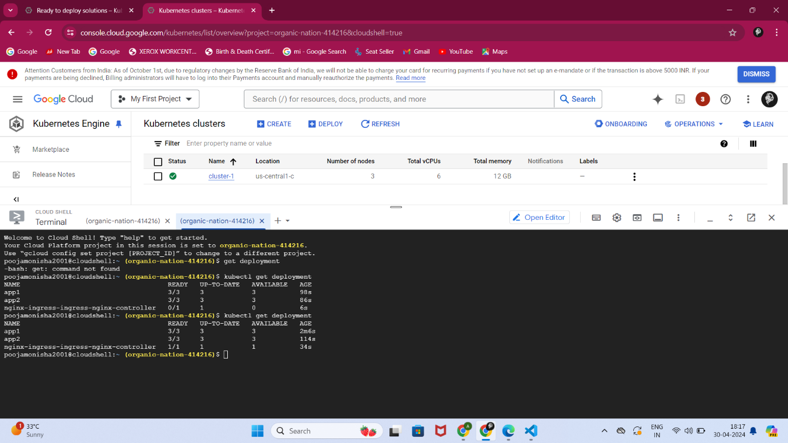

**Setup Ingress Route**

Setup Ingress controller in K8s cluster and map local ip into some domain name

and use that domain name to route 2 application.

Ex: 1st application >> www.example.com

2nd application >> [www.example.com/2nd](http://www.example.com/2nd)

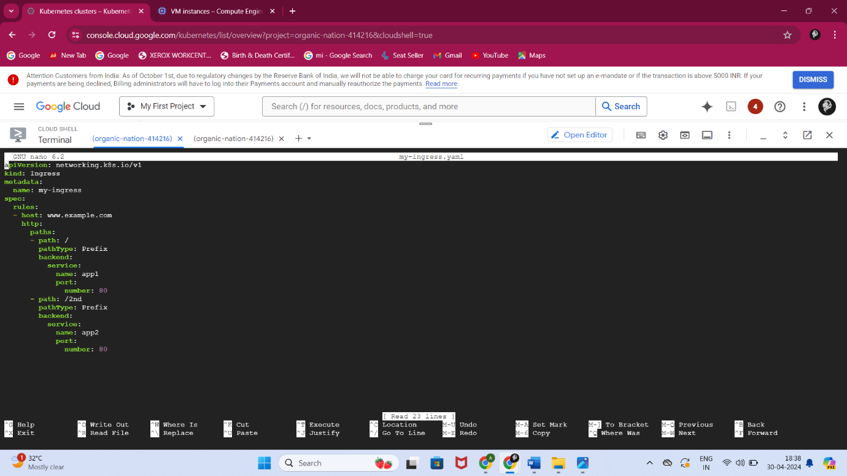

Access with domain name in browser

